Objects and its internal representation

Objects are the main data type in JavaScript. Objects are different from normal data (e.g. number, string, boolean, etc.). Background information has a single  value, but objects can hold more than one value: value pairs. These keys can be manipulated or executed in the context of objects by calling them objects and  methods respectively. These objects are very different from JavaScript's  traditional data types (multiple, string, boolean, null, undefined, and symbol) because these underlying data types store a single value (depending on their type).

* They are used to represent complex data structures and are essential for building applications.
* Internally, objects in JavaScript are typically implemented using either a hash table or a similar data structure. This implementation allows for fast access to values based on their keys.

**HASH TABLE:**

* Objects in JavaScript are often implemented using a hash table or a similar data structure.
* Each property (key-value pair) of the object is stored in the hash table.
* The keys are hashed, which allows for efficient lookup of values based on their keys.
* Hash tables provide fast access to properties, typically with an average time complexity of O(1) for property access.

**PROPERTIES:**

* Each property of an object is stored with its corresponding key and value.
* Properties can be accessed using dot notation (e.g., object.property) or bracket notation (e.g., object['property']).

**PROTOTYPE CHAIN:**

* JavaScript objects also have a prototype chain, which allows them to inherit properties and methods from other objects.
* If a property is not found in the object itself, JavaScript will look for it in the object's prototype, and recursively up the prototype chain until it finds the property or reaches the end of the chain.

**Dynamic Nature:**

* JavaScript objects are dynamic, meaning properties can be added, modified, or removed at runtime.
* This dynamic nature allows for flexibility in working with objects and is a fundamental aspect of JavaScript's object model.

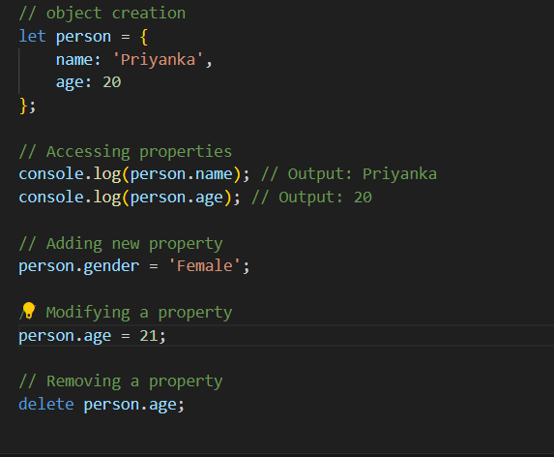

**Explanation:** Person is an object with properties name and age. Internally, these properties are stored in a hash table, allowing for efficient access and manipulation.